Step 1 – USA Rugby for new players (see below for returning players)
Don't be put off by the steps below, registration is actually fairly intuitive and quick. We've just set these out to be as helpful as possible.
Watch this video first - How To Set Up A Rugby Xplorer Member Profile
Video tutorial: https://youtu.be/aZjB1uoHm20
Note- this Registration covers your player for the entire year from Sept 1st 2025 to August 31st 2026. You will not need to pay again for Spring rugby or Summer/Fall 7's tournaments
Go to https://myaccount.rugbyxplorer.com.au (yes, the .au is correct and I've no idea why...) Enter your contact info and it’ll send you a confirmation link that’ll take you back to the homepage.
Enter in your email & password and set your player’s profile (RX assigns permissions to individual people. It doesn’t require multiple logins for different children in the same household so if registering more than one athlete, complete the first registration and then click 'register another player' at the bottom of the screen)
Note that this account & player ID # will stay with the player through their entire rugby journey
You may see “You don't have a Rugby ID,” This is of course correct if you are a new player.

MAKE SURE that USAR National is selected (and not Rugby Australia or anything goofy!)
- Select ‘Register’ in top left corner
- Select ‘Find a Club’
  - Enter Club Name as Charlotte Cardinals Rugby (MRRC benefits from Cardinals insurance cover which is superior to USA Rugby’s cover and players won’t have to transfer for Spring Rugby)
- Select the Player(s) to Register (here you can link your family members if you wish)
- Take note of the USA ID number. This is the same as the CIPP number (these terms are interchangeable) as you’ll need this for Step 2
- Select Player (not Admin or Volunteer)/School/Season and complete other questions.
- An Order Summary will show. Click agree.
- Pay the $73.80 directly to USA Rugby
Move to Step 2 – the Jotform registration for Marvin Ridge Rugby Club

Step 1 – USA Rugby for returning players
Note- this Registration covers your player for the entire year from Sept 1st 2025 to August 31st 2026. You will not need to pay again for Spring rugby or Summer/Fall 7's tournaments
Go to https://myaccount.rugbyxplorer.com.au (yes, the .au is correct)
- Enter in your personal email & password to sign in
- The system will show your imported profile from last year for you to check
- Select ‘Register’ in top left corner
- Select ‘Find a Club’
  - Enter Club Name as Charlotte Cardinals (MRRC benefits from Cardinals insurance cover which is superior to USA Rugby’s cover and players won’t have to transfer for spring rugby)
- Select the Player(s) to Register
- Take note of your USA ID number. This is the same as the CIPP number (these terms are interchangeable) as you’ll need it for Step 2.
- Select Player/High School/Season etc
- Pay the $73.80 directly to USA Rugby
Move to Step 2 – the Jotform registration for Marvin Ridge Rugby Club
If you get stuck, watch this video tutorial: https://youtu.be/aZjB1uoHm20

Step 2 - Marvin Ridge Rugby Club Registration
Jotform: You’ll need a JotForm account to register. If you don’t already have one, creating an account takes 30 seconds.
Please cut & paste the following link:
https://form.jotform.com/252866281788171
Note - click the submit button twice and when your completed Jotform goes through, you'll see a message "Thank you - your submission has been received"

Payment by Zelle or Venmo is preferred.
If by Check, please make payable to Marvin Ridge Rugby Club
For Zelle use marvinridgerugby@gmail.com or QR Code below.

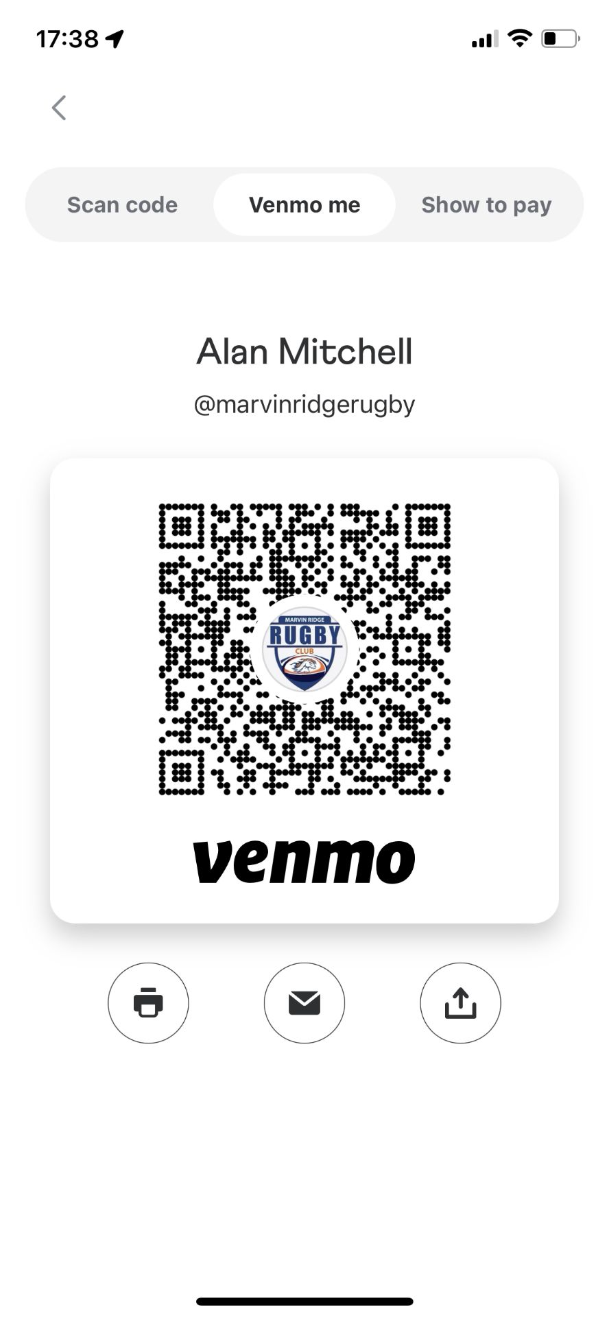
Venmo is @marvinridgerugby

Thank you.

